# CS 255 Business Requirements Document Template

Complete this template by replacing the bracketed text with the relevant information.

This template lays out all the different sections that you need to complete for Project One. Each section has guiding questions to prompt your thinking. These questions are meant to guide your initial responses to each area. You are encouraged to go beyond these questions using what you have learned in your readings. You will need to continually reference the interview transcript as you work to make sure that you are addressing your client’s needs. There is no required length for the final document. Instead, the goal is to complete each section based on your client’s needs.

**Tip:** You should respond in a bulleted list for each section. This will make your thoughts easier to reference when you move into the design phase for Project Two. One starter bullet has been provided for you in each section, but you will need to add more.

## System Components and Design

### Purpose

*What is the purpose of this project? Who is the client and what do they want their system to be able to do?*

* The client is DriverPass and the owner is the project sponsor Liam. Their IT officer is Ian.
* The systems should be able to train students for their driving test at their local DMV. The system should be able to provide online classes and practice tests.
* Potential Scope: DriverPass will provide them with on-the-road training.

### System Background

*What does DriverPass want the system to do? What is the problem they want to fix? What are the different components needed for this system?*

* DriverPass wants the system to host a series of online classes and practice tests.
* The problem they want to fix is the failure rate of driving tests at the DMV.
* Components look like the following:
  + User management
  + Scheduling service
  + Package/Product offering
  + Package/Product progress

### Objectives and Goals

*What should this system be able to do when it is completed? What measurable tasks need to be included in the system design to achieve this?*

* The system should be accessible online (after rebuttal from Sam on offline).
* Access data online from any computer or mobile device
* Download reports and ‘some information’ that I can work on in Excel.
* Varying levels of access. Someone needs to be able to function as a user administrator to reset passwords or block access if someone is let go.
* Manage an audit log for who made reservations, who canceled it, and who modified it last.
* Customers need to be able to make reservations for driving lessons. They are two hours long and the customer should be able to select day and time of day for these reservations. It should be available online or they can call/visit the office to schedule.
* There needs to be a way to identify the driver who is scheduled with the customer. We need to be able to manage customer, driver, and car all-together
* There are 4 major roles, ‘big boss’, ‘IT officer’, ‘Secretary’, and ‘Users/Customers’.
* There are three current packages all with a configurable set of hours, sessions, and material. Nearly all aspects should be configurable: Package, hours, sessions, online classes, content, and practice tests.
* Packages should be disable-able at launch.
* Registration of an account should happen over the phone that records : first name, last name, address, phone number, state, credit card number, expiration date, security code, pick up location and drop-off location.
* Tests and practices should be current with DMV requirements (INTERFACE). We should get a notification whenever this changes.
* System should run in the cloud to avoid backup and security.
* UX/UI Sketch:

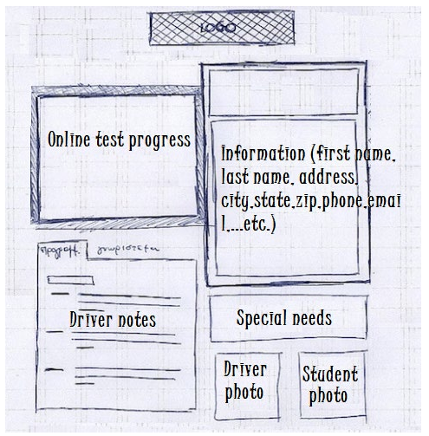

* Test progress should be available to the user
* Allow for driver feedback:

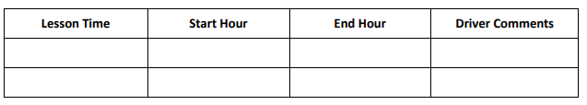

## Requirements

### Nonfunctional Requirements

*In this section, you will detail the different nonfunctional requirements for the DriverPass system. You will need to think about the different things that the system needs to function properly.*

#### Performance Requirements

*What environments (web-based, application, etc.) does this system need to run in? How fast should the system run? How often should the system be updated?*

* Web-based would work if Liam agrees to download reports before being offline. If Sam is the only one who needs access to data offline potentially a secondary service can be done for him alone.
* Cloud-hosted as also mentioned so that Ian does not have to deal with backup and security.
* User interface feedback and response should be within 5 seconds of an action initiated by a user. If the action cannot be done in 5 seconds, a form of progress feedback should be provided.
* There is at least one major update expected but with no timeline given. This has to do with configuring packages.
  + “We can talk about adding or removing modules for a future release, but it does not need to be in the system we build now.”
* There should also be updates as the DMV updates their rules or policies.

#### Platform Constraints

*What platforms (Windows, Unix, etc.) should the system run on? Does the back end require any tools, such as a database, to support this application?*

* A database is absolutely necessary to record schedules, customers, packages, instructors, notes and many more.
* There is no specific platform mentioned, only that it is web-based. Browser support should have been requested.
* No cloud providers were requested either leaving this open to any of them.

#### Accuracy and Precision

*How will you distinguish between different users?* *Is the input case-sensitive? When should the system inform the admin of a problem?*

* Currently customer information is managed through first name, last name, address, phone number, state. Identification would have to be done manually through the individuals in which they register or by adding an additional attribute to identify uniqueness such as an email-address, phone number is close to identifying uniqueness.
* Input should not be case sensitive as this allows Tom and tom to be unique, when in context are the same people.
* The only mention of notification is whenever DMV updates occur that change policies, sample questions or rules.

#### Adaptability

*Can you make changes to the user (add/remove/modify) without changing code? How will the system adapt to platform updates? What type of access does the IT admin need?*

* There is an ask to be able to manage users to reset passwords as needed. Liam also needs people to be able to add customers if they dial over the phone. There are also instances to block/suspend accounts if drivers or admins are let go.
* There is a requested adaptability of packages, right now the ability to disable is sufficient. However, it will increase to be able to edit from the three initial packages.

#### Security

*What is required for the user to log in? How can you secure the connection or the data exchange between the client and the server? What should happen to the account if there is a “brute force” hacking attempt? What happens if the user forgets their password?*

* Nothing is explicitly provided for login: The UX sketch does include email so an email + password seems sufficient. If not, a phone number could be sufficient.
* Message signing and encryption would be required for data exchange. TSL_ECDHE_RSA_WITH_AES_128_CBC_SHA is a decent starting point. More options can be identified to prevent data leaks between client & server.
* Security performance on brute force should be defined such as “Greater than 5 years to brute force hack”. Regarding recovery, options should be discussed with Ian and Liam.
* Ian has mentioned that users should be able to automatically trigger a password reset.

### Functional Requirements

*Using the information from the scenario, think about the different functions the system needs to provide. Each of your bullets should start with “The system shall . . .” For example, one functional requirement might be, “The system shall validate user credentials when logging in.”*

* The system shall allow for customers and administrators to create an account
* The system shall allow for customers to reset their password automatically
* The system shall allow for an administrator to reset customer passwords, edit user accounts, and suspend user accounts
* The system shall validate user login
* The system shall provide a repository for online class content including practice tests
* The system shall allow for a customer to schedule reservations/appointments
* The system shall allow for administrators and customers to edit and cancel reservations/appointments
* The system shall allow for administrators to suspend packages used in reservations/appointments
* The system shall notify administrators whenever a new rule policy or question is proposed by the DMV.
* The system shall host a profile page showing general information, driver notes, package progress, driver and student photo, and special needs.

### User Interface

*What are the needs of the interface? Who are the different users for this interface? What will each user need to be able to do through the interface? How will the user interact with the interface (mobile, browser, etc.)?*

* The user interface should host the following information:
  + Login Screen
    - Should also contain a way to automatically reset password
    - **User Actions:** Login, Reset password
  + Profile Page
    - Online Test Progress
    - General Information:
      * First Name
      * Last Name
      * Address
      * City
      * State
      * Zip
      * Phone #
      * Email Address
    - Driver notes
      * Lesson Time
      * Start Hour
      * End Hour
      * Driver Comments
    - Special needs
    - Driver photo
    - Student photo
    - **Missing**: A way to access online class content if package 3 is purchased
    - **User Actions:** Users should be able to update their general information, student photo, and special needs. **Missing**: Schedule appointments, access online class content.
  + **Missing**: A way to schedule an appointment online
    - Should contain three available packages
    - Credit card #, expiration date, security code(Should potentially be housed in general info)
    - Day and time for appointment
    - Pick-up location
    - Drop-off location
    - **User Actions:** finalize appointment

### Assumptions

*What things were not specifically addressed in your design above? What assumptions are you making in your design about the users or the technology they have?*

* The user will have internet access.
* Users will have an email address and a phone.
* Users have a basic understanding of web applications and peripherals such as keyboard, mouse, touchscreen.
* User interface is simple and labeled well enough that the application does not need a tutorial.

### Limitations

*Any system you build will naturally have limitations. What limitations do you see in your system design? What limitations do you have as far as resources, time, budget, or technology?*

* Needs to be web-based - preferably off cloud.(Constraint)
* Total of 6 resources Sam, Jennifer, Toni, Clark, John, and myself
* No time limitations, however, schedule aims for May 10th.
* No mentioned budget limitations

### Gantt Chart

*Please include a screenshot of the GANTT chart that you created with Lucidchart. Be sure to check that it meets the plan described by the characters in the interview.*

